Name:__________________________________ September 8, 2014- September 12, 2014
Eastern Philosophy-Physical Education Homework
Due: Monday, September 15, 2014
This week each scholar needs to complete the below sequence 3 times this week and have a parent/guardian sign off below.
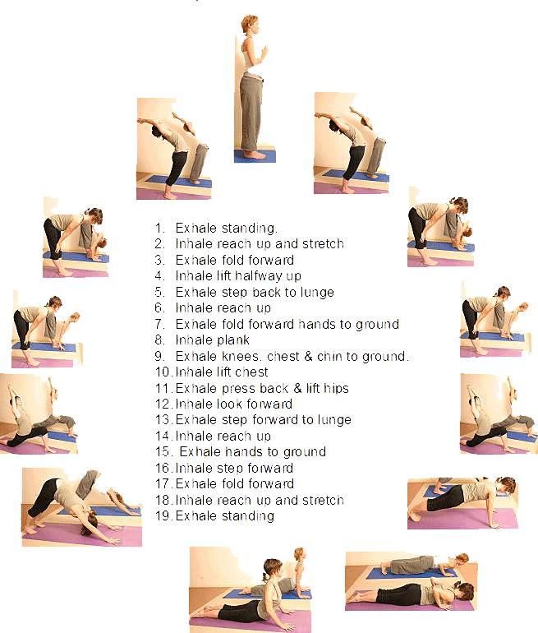
Parent/Guardian Signature:_______________________________________________

